The Osani Circle Game
http://www.connectingdotz.com/osani-circle-game.html
“When people see this image, it draws their attention. When they read what it’s about, they fall in love.”
Efé children of the Ituri Forest in Zaire (Rep. of Congo, central Africa) begin the Osani game by sitting in a circle, feet touching, all connected. Each child in turn names a round object like the sun (oi), the moon (tiba), a star (bibi) an eye (ue) and then goes on to name a figurative expression of “round” like the circle of the family, togetherness, a baby in the womb, or the cycle of the moon. As players fail to come up with a term that is “circular” they are eliminated from the game. Eventually, only one remains. Tradition has it that this player will live a long and prosperous life.

This description is printed on the Osani Poster and the back of the Osani Greeting Cards.
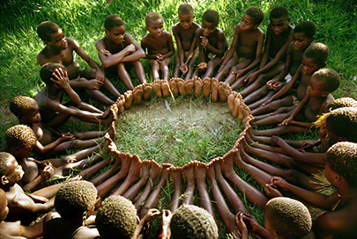
The Story
Belgian adventurer, naturalist, humanitarian and art collector Jean-Pierre Hallet was born in 1927, son of the Belgian painter Andre Hallet who lived in the Congo. At six years of age, Jean-Pierre left his Efé friends to attend school in Europe. (By that time, he was already the height of an average adult native). He returned at age 21, 6’5”, with a degree from the Sorbonne in Agronomy and Sociology.

Jean-Pierre became a blood brother of the Lega, Tutsi and Nande tribes, and was initiated as a Massai warrior. When I met him in 1984 (after seeing Osani in a magazine and calling the publication to track him down). I was immediately struck by his passion for the Efé. He told me he spoke 17 African dialects and had traveled in Africa extensively. But it was the Efé people, the so-called “Pygmies”, that captured his heart, and he spent most of his life in their service. In 1974 he began The Pygmy Fund with the mission of saving the Efé from extinction and preserving their way of life, with self-reliance and dignity. His persistence and dedication led to a Nobel Peace Prize nomination.
As he stood before me, one-armed (having blown off the other arm while dynamite fishing in 1955 at Lake Tanganyika) he was a most impressive presence. When he told me of his mission to provide seeds, tools, medicine and farming methods I knew I had to help, and agreed to write a grant proposal. It brought in twenty-five thousand dollars he used to bring winged bean farming to the Efé.
Jean-Pierre explained that this image, his one and only of this traditional game, was taken during the 60’s. I sort of fell in love with the Osani circle; it drew me in, and reminded me of my fundamental connection to the earth, to the natural changes that occur in life, to a desire for community and a deep respect for traditions that carry such sensibility and wisdom. I felt the photo spoke, instantly, to everything I cared about. And I could see it moved others the same way. So… I hung it on my wall.
Decades passed. When in L.A. I would visit Jean-Pierre’s shop which carried African art and artifacts. I would buy a few beads, and we’d talk. And then one day I acted on impulse: after 25 years of friendship I called Jean-Pierre to acquire the Osani exclusive rights, with the hope of making this wonderful image more accessible. My call came on the very day he was diagnosed with terminal leukemia.
It is with great sadness I must report that Jean-Pierre Hallet passed away only 90 days later (January 2004). He was truly larger than life in every respect – a remarkable man.
To read more about Jean-Pierre Hallet’s adventurous life, please see www.pygmyfund.org or read here.

